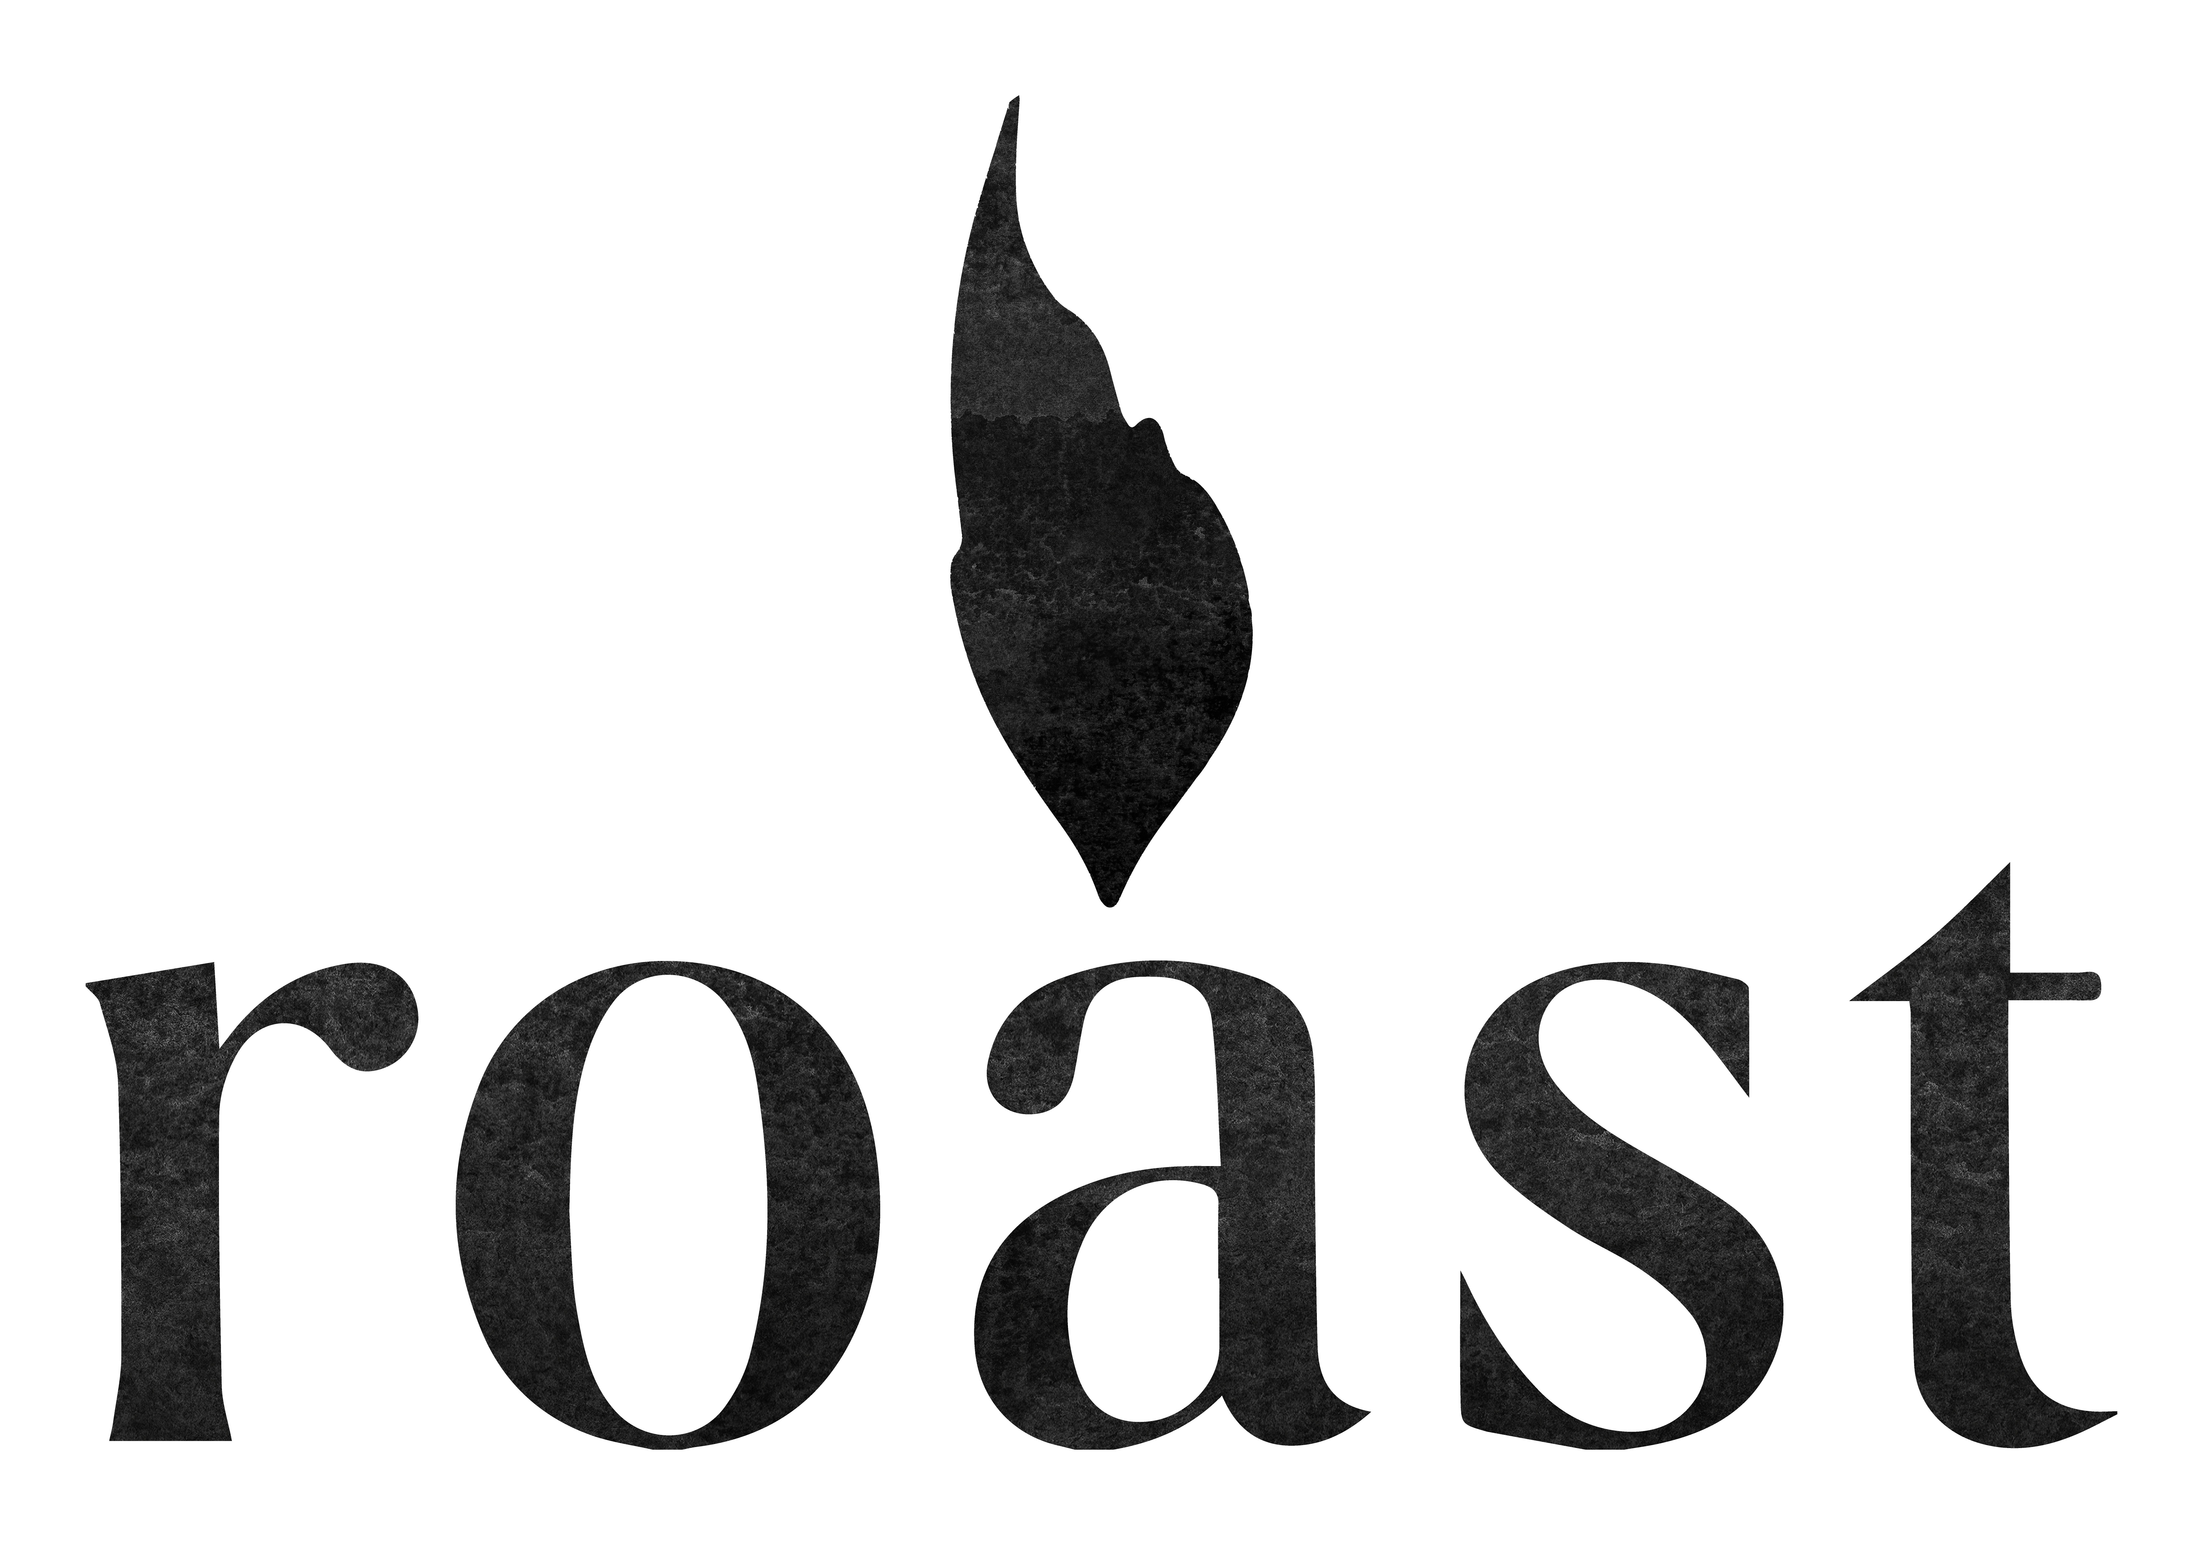

KIDS MENU

1 COURSE 7.50 / 2 COURSES 12

Mains

Roast Beef, veggies, and roasties, with Yorkshire pudding

Roast chicken, veggies, and roasties

Mini Fish & Chips , Garden Peas

Cauliflower cheese

Dessert

Vanilla ice cream, English berries, meringue

